II интеллектуальная игра для учащихся 3-4 классов
«Путешествие в страну Гуманитарию»
Английский язык
1. Посмотрите на фотографию и отметьте в бланке ответов слова, которые вы видите на изображении:
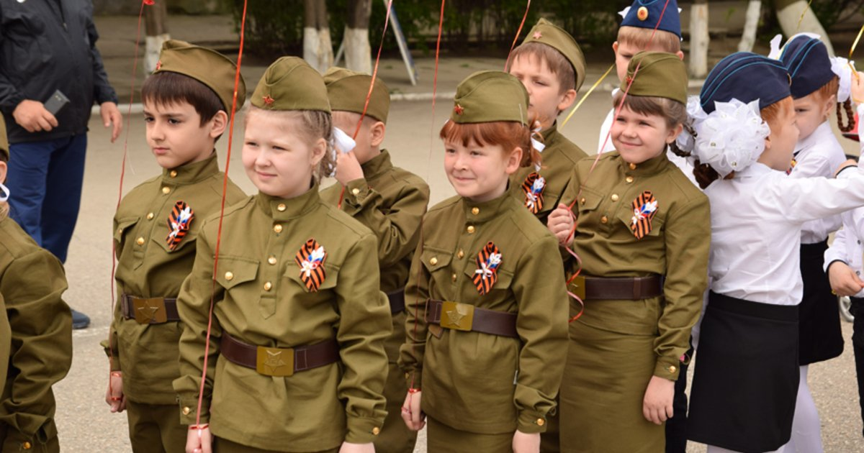
1 | a war veteran
2 | St. George’s ribbon
3 | flowers
4 | children
5 | a parade
6 | a tank
7 | soldier clothes
8 | ﬁreworks
(4 балла)
2.Прочитайте текст и ответьте на вопросы:
In Russia and other countries Victory Day is one of the great holidays of the year. In all cities and towns there are decorations, flags and flowers in the streets, in the shop windows and on the front of the large buildings. On Victory Day morning there are meetings and demonstrations of the veterans who fought in the war. On that day there is a military parade in all big cities of our country. There are a lot of people in the streets and squares. They celebrate this holiday and give war veterans flowers and souvenirs. Many people go to see their friends or go for walks in the parks. In the evening there is a holiday salute and a minute of silence to remember all those who did not come back from the war.
1. Where do people celebrate Victory Day?
2. How do people decorate their cities?
3. What parade is there in all big cities?
4. What do people give war veterans?
5. Is there a holiday salute in the evening?
6. How do people spend their time on Victory Day?
(6 баллов)
3. Закончите предложения, выбрав один из вариантов:
1. The Great __________War began on 22 June 1941.
a) World b) Civil c) Patriotic
2. There is a parade and fireworks in ________Square every spring.
a)Lenin b) New c ) Red
3. There are _______monuments and Victory memorials in our country.
a) no b) many c ) any
4. On _________all the people in our country celebrate Victory Day.
a) November 4 b) February 23 c) May 9
5. We congratulate war veterans and give ______flowers.
a) her b) him c ) them

(5 баллов)

Бланк ответов
Код команды

II интеллектуальная игра для учащихся 3-4 классов
«Путешествие в страну Гуманитарию»
Английский язык

1.
1 | 2 | 3 | 4 | 5 | 6 | 7 | 8

2.
1
2
3
4
5
6

3.
1 | 2 | 3 | 4 | 5

